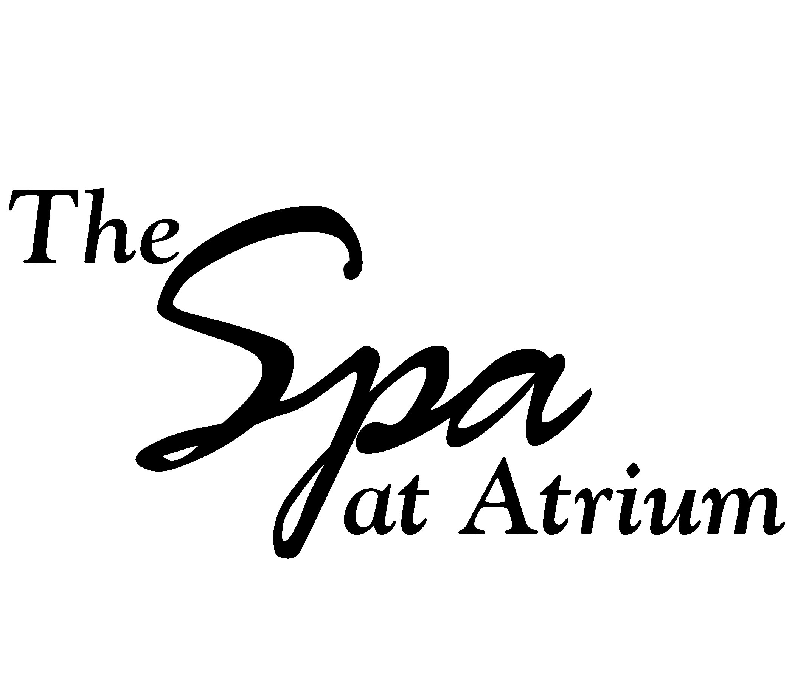
Client Information

Personal Data DATE ____________________

Name: _________________________________ Phone (H) ___________________
Address: _________________________________ Phone (C)____________________
City/State: ________________________________ Phone Carrier ________________
Zip Code ______________ (For appointment reminders)
DOB:______________________________________ Phone (W) __________________

Email Address:_____________________________ Would you like to receive email appointment reminders Y ____ No _____
Occupation:_________________________________
Emergency contact:___________________________ Phone:______________________
What service (s) are you having today?______________________________________________

Are you allergic to any of the following?(please circle each that apply)
Fruits Nuts Vegetables Metals Latex Medications NA Other___________________________________________

If so, what is the reaction:______________________________________________

List of current medications including over the counter, herbs and supplements:

________________________________________________________________________

Are you currently seeing a medical practitioner? ____yes____no. If yes, please explain for what condition?_______________________________________________________

Recent (past 3 months) surgeries:________________________________________

Recent (past 3 months) accidents or injuries_____________________________________________________________

Do you wear contact lenses?____yes____no.

Do you wear hearing aids?____yes____no.

Massage History/Treatment Information
(complete this section only if you are having a massage)

Referred by:___________________________________
Have you ever received a professional massage? ____Yes____No.
If yes, frequency?___________________Date of last massage________________
Are you pregnant?__Yes___No. If yes, name of obstetrician_____________________
Are you nursing? ….Yes…..No
What results are you looking for from your massage session?_____________________
______________________________________________________________________
Prioritize the areas of your body that you would prefer to be massaged?______________
_______________________________________________________________________
Is there an area of the body you prefer not to have massaged?______________________
_______________________________________________________________________

Skin Care History/Treatment Information
(complete this section only if you are having a facial)

Please check the products you currently use:
____Cleanser____Toner____Moisturizer____Exfolient____Masque____Eye Cream
Brand Names:__________________________________________________________
Frequency:_____________________________________________________________
Dermatologist?____yes____no
Name of Dermatologist:__________________________________________________
Tanning?____yes____no. Sun or Tanning Bed? (Please circle)
Waxing? ____yes____no. Any reaction? ____If so what?_____________
Last skin care treatment?___________________________Date_________
Are you using or taking any of the following?____Accutane____Alpha Hydroxy Acid
____Glycolic acid____Chemical Peels ____Retin A____Other.
What kind of results are you looking for in your skin?___________________________
______________________________________________________________________

I understand that I am accepting any reaction that may occur from waxing, skin care, nail services or massage service.

It is my choice to receive massage therapy; I realize that the treatment is being given for the well being of my body and mind. This includes stress reduction, relief from muscular tension, spasm or pain or for increasing circulation or energy flow. I agree to communicate with my practitioner any time I feel like my well being is being compromised.

I understand that Massage Therapists, Estheticians, and Nail Technicians do not diagnose illness, disease or any physical or mental disorder, nor do they prescribe medical treatment, pharmaceuticals or perform spinal thrust manipulations. I acknowledge that massage therapy, acupressure, reflexology or reiki is not a substitute for medical examination or diagnosis and that it is recommended that I see a primary health care provider for that service.

Signature____________________________________Date_________________
Detailed Health History

Please complete if you are receiving a therapeutic or hot stone massage or medi spa service

Musculo-Skeletal Please list medications you are
For any of these conditions:
____tendonitis
____bursitis
____broken/fractured bones
____arthritis
____fibromyalgia
____low back, hip or leg pain
____neck, shoulder, arm pain
____headaches/jaw pain

Circulatory

____ heart condition
____blood clots
____high or low blood pressure
____lymphadema
____bruising

Nervous System

____numbness/tingling
____chronic pain
____fatigue
____sleep disorder

Other
____ diabetes
____cancer
____sinus problems

Signature____________________________________Date_________________

